

LAPTOP PRICE PREDICTION USING MACHINE LEARNING

- REPORT BY ZAINAB SAEED

**Contents**

**PROBLEM STATEMENT:** 4

**BUSINESS NEED ASSESSMENT:** 4

**TARGET SPECIFICATIONS AND CHARACTERIZATIONS:** 5

**EXTERNAL SEARCH (INFORMATION SOURCES/REFERENCES):** 5

**BENCHMARKING ALTERNATE PRODUCTS:** 5

**APPLICABLE PATENTS AND REGULATIONS:** 6

**BUSINESS OPPORTUNITIES:** 8

**CONCEPT GENERATION:** 8

**CONCEPT DEVELOPMENT:** 9

**CODE IMPLEMENTATION (SMALL SCALE):** 9

**BUSINESS MODEL:** 14

**MARKET ANALYSIS:** 15

**FINANCIAL EQUATION** 15

**Revenue Streams:** 15

**Conclusion** 16

**Your Guide to Smarter Laptop Investments.**

# **PROBLEM STATEMENT:**

Predicting the price of laptops based on various features like brand, processor type, RAM, storage, screen size, etc. The problem arises due to the vast range of laptops with varying configurations and prices, making it difficult for consumers to determine a fair price for a given laptop. The challenge is to build an accurate model that can predict laptop prices based on these factors.

**Why this field?** In today’s fast-paced technological world, the decision to buy a laptop is crucial for consumers, and knowing the right price is key to making a well-informed purchase. By utilizing AI and machine learning techniques, we aim to help consumers and businesses alike in predicting and optimizing laptop pricing.

# **BUSINESS NEED ASSESSMENT:**

* **Consumer Challenges:** Many consumers struggle with determining if the price of a laptop is reasonable based on its specifications.
* **Retailer Challenges:** Retailers often overprice or underprice laptops due to the complexity of price-determining factors.
* **Impact of Prediction Model:** A predictive model can assist consumers by suggesting optimal laptop prices and help retailers adjust pricing strategies.

# **TARGET SPECIFICATIONS AND CHARACTERIZATIONS:**

* **Model Goals:** The goal is to develop a regression model that predicts laptop prices based on attributes such as brand, processor, RAM, storage, and screen size.
* **Data Considerations:** The model must handle large datasets with multiple features while maintaining high accuracy.
* **User Consideration:** The final application (web or mobile) must be user-friendly, allowing customers to input laptop specifications and receive an accurate price prediction.

# **EXTERNAL SEARCH (INFORMATION SOURCES/REFERENCES):**

* **REFERENCES:**

1. [**Product Price Prediction**](https://medium.com/@jesuslsw21/predict-the-price-of-products-using-machine-learning-86c647a68384)
2. [**Laptop Price Prediction**](https://www.ijnrd.org/papers/IJNRD2303124.pdf)

* **DATASETS:**

Laptop Price Dataset from Kaggle: Laptop Price Prediction Dataset

# **BENCHMARKING ALTERNATE PRODUCTS:**

* **Companies like Best Buy and Amazon** leverage machine learning algorithms for dynamic pricing. These models take into account various factors, including customer demand, competitor pricing, and historical sales trends. Machine learning enables these companies to adjust prices in real-time, ensuring competitiveness in the market while optimizing profit margins. Additionally, predictive pricing can enhance customer satisfaction by offering personalized discounts or price suggestions tailored to an individual’s purchasing behavior.
* **Price Comparison Websites:** Existing platforms like PriceGrabber or Shopzilla offer price comparisons across multiple online stores, helping customers find the lowest available price for laptops. However, these tools typically rely on static data and lack the sophisticated algorithms that machine learning-driven models use. For example, these tools often fail to predict future price movements or adjust in real-time to competitor price shifts. Machine learning-based models, on the other hand, can continuously update pricing predictions and offer a more personalized and accurate shopping experience.

In contrast to traditional price comparison websites, machine learning can analyze vast amounts of data from various sources such as customer reviews, seasonal trends, and even news articles, further improving the accuracy of price recommendations. These improvements could lead to the creation of a more intelligent pricing tool that not only compares prices but also provides predictions about the optimal time to purchase a laptop.

# **APPLICABLE PATENTS AND REGULATIONS:**

* **Patents:** While there are no specific patents directly related to laptop price prediction models, machine learning techniques used for pricing and recommendation systems often fall under broader patent categories. For example, several companies hold patents for dynamic pricing models that adapt based on customer behavior, market demand, and competitor actions. These types of models are commonly employed in retail, travel, and e-commerce industries. Additionally, patents related to recommendation engines, which provide personalized suggestions based on user preferences and historical data, may also apply to the technologies used in laptop price prediction systems. Companies such as Amazon, eBay, and other e-commerce platforms are known for holding patents around these kinds of technologies. Understanding these patents is important to avoid potential legal disputes or infringement when implementing machine learning models for pricing.
* **Regulations:** Several regulatory frameworks impact the development and deployment of machine learning models, especially in areas related to consumer data, intellectual property, and fair market practices. Some of the key regulations include:
  + **Data Protection Laws:** Consumer data privacy and protection are a primary concern when using machine learning models to predict laptop prices. Laws like the General Data Protection Regulation (GDPR) in Europe and the California Consumer Privacy Act (CCPA) in the U.S. set stringent rules about collecting, processing, and storing consumer data. These laws require companies to ensure that customer data is handled ethically, with explicit consent obtained before collecting any personal information for model training. Failure to comply with these regulations could result in heavy fines and reputational damage.
  + **Intellectual Property Rights:** The creation of machine learning models involves developing proprietary algorithms and systems, which may be eligible for intellectual property protection, such as copyrights or trade secrets. These protections safeguard the unique aspects of a model, such as the algorithm's architecture, the data sets used for training, and the overall system design. It is essential for companies to properly document and protect their intellectual property to prevent unauthorized use by competitors or third parties.
  + **Fair Pricing Regulations:** In some jurisdictions, pricing practices are regulated to ensure fairness and transparency in the market. For example, price discrimination based on consumer characteristics (such as location or browsing history) could potentially violate consumer protection laws. Regulators may monitor the use of machine learning models in pricing to ensure that they do not lead to unfair or discriminatory practices, such as price gouging during high-demand periods or biased pricing based on personal data.
  + **Anti-Trust and Competition Laws:** The use of advanced algorithms in pricing could raise concerns regarding anti-competitive behavior. For instance, if multiple companies use similar machine learning models for dynamic pricing, they could unintentionally engage in price collusion or create monopolistic pricing practices. Regulatory bodies such as the Federal Trade Commission (FTC) in the U.S. may review the impact of these practices on market competition to prevent anti-competitive outcomes.

# **BUSINESS OPPORTUNITIES:**

The target market for a laptop price prediction model includes e-commerce platforms, online retailers, and both large and small brick-and-mortar stores aiming to optimize their pricing strategies for laptops. By leveraging machine learning to offer dynamic pricing, these businesses can stay competitive by adjusting prices based on real-time market trends, competitor pricing, and consumer demand. In addition to retailers, secondary markets such as consumers could also benefit from the model by using it as a price comparison tool when shopping for laptops both online and in physical stores. This provides value to end-users by helping them identify the best deals and make informed purchasing decisions. Furthermore, the scalability of the model offers significant growth potential, as it can be adapted to predict prices for other electronics like smartphones, tablets, and home appliances. This opens up a broader range of business opportunities, from creating specialized price optimization tools for various tech sectors to partnering with global retailers looking to incorporate machine learning into their pricing strategies. The flexibility and adaptability of the model ensure that it can be customized to fit various market needs, thereby driving further expansion and profitability.

# **CONCEPT GENERATION:**

* **The Concept:** We aim to create a tool that uses machine learning algorithms to predict laptop prices. This tool will be integrated into e-commerce platforms and retail websites for dynamic pricing.
* **Challenges:** Data quality and model interpretability are key challenges. The model must not only predict prices accurately but also explain the reasoning behind predictions.

# **CONCEPT DEVELOPMENT:**

* **Data Collection:** The first step involves collecting data from various e-commerce websites, including attributes like laptop specifications and historical pricing trends.
* **Feature Engineering:** Features such as brand, processor type, RAM size, and storage type will be essential.
* **Model Development:** After performing exploratory data analysis (EDA), we will implement regression models (e.g., linear regression, random forests, or gradient boosting) to predict the prices.
* **Model Evaluation:** The model will be evaluated using metrics such as Mean Absolute Error (MAE) and R-squared to assess accuracy and reliability.

# **CODE IMPLEMENTATION:**

**GitHub Link:** [**GitHub Link**](https://github.com/ZainabSyed88/Machine-Learning-Engineer-Internship/tree/main/Project%203.0)

* **Dataset Features:** The dataset includes laptop attributes such as brand, processor, RAM size, storage type, screen size, and price.
* **Exploratory Data Analysis:** Initial analysis showed the strong correlation between processor type and price, as well as storage size and price.
* **Model Performance:** Early results using linear regression indicated a promising fit, but further hyperparameter tuning will be done to improve accuracy.

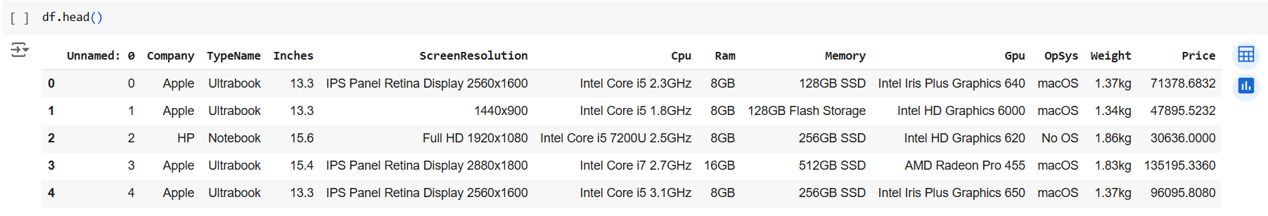

This code creates a bar plot to visualize the relationship between laptop companies ('Company') and their corresponding prices ('Price').The x-axis labels are rotated vertically for better readability, especially when there are multiple company names. The plot provides a clear comparison of laptop prices across different companies, making it easy to identify pricing patterns and trends.

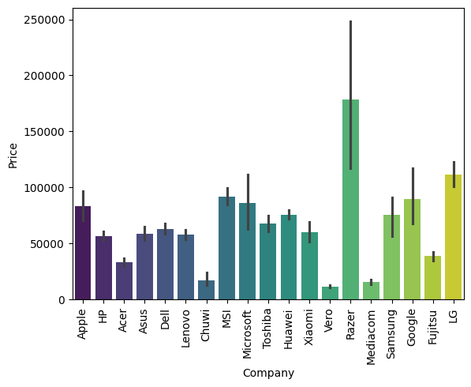

To enhance the database and improve the predictive power of the model, I performed feature engineering by adding new columns such as **TouchScreen**, **IPS**, **ppi**, **CPU Brand**, **HDD**, **SSD**, and **GPU Brand**. These features were derived from existing data and provide more granular insights into the specifications of laptops. This step not only enriches the dataset but also helps capture critical factors influencing laptop prices, enabling more accurate predictions and deeper analysis.

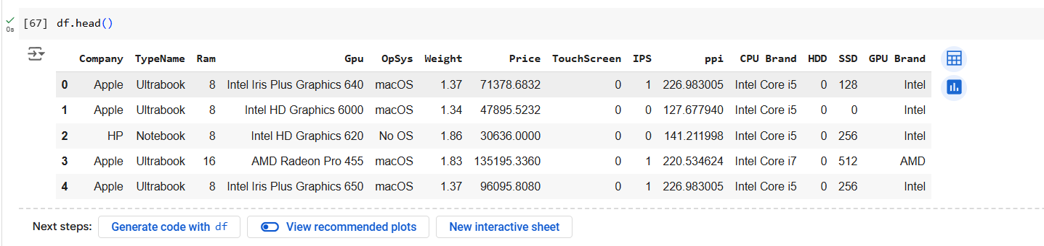

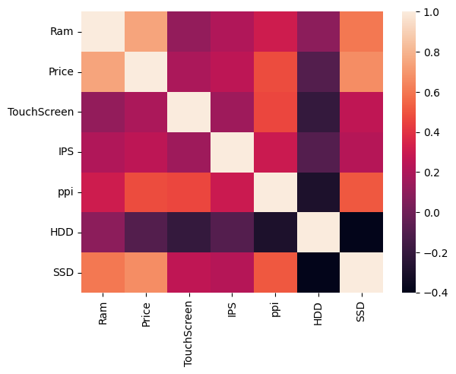

Based on the heatmap:

* **Price** has a strong positive correlation with **RAM** and **ppi**, indicating these features significantly influence the price.
* **SSD** also shows a moderate positive correlation with **Price**, suggesting laptops with SSDs are generally more expensive.
* **HDD** has a negative correlation with **Price**, implying laptops with HDDs tend to be less expensive.
* There is no significant correlation between features like **TouchScreen** or **IPS** with **Price**, indicating these might not strongly affect the price.

This suggests focusing on **RAM**, **ppi**, and **SSD** for predicting or analyzing laptop prices.

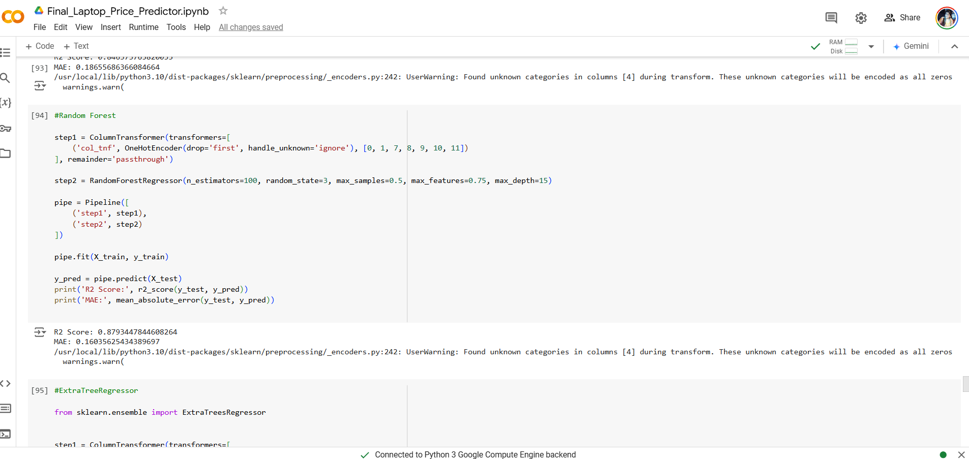

Based on the analysis of different regression algorithms used in the laptop pricing dataset, XGBoost Regressor performed better with R² score in terms of accuracy, followed by Random Forest Regressor and Gradient Boosting Regressor. Besides, XGBoost’s advanced gradient-boosting techniques, efficient handling of missing values, and capability to uncover complex non-linear relationships make it unique. Our initial attempts at Linear Regression and Ridge Regression performed fairly well but were unable to capture the underlying complexity of the data. As they perform naturally well with interaction of features and reducing error, XGBoost was the best model for this use case.

# **BUSINESS MODEL:**

We will adopt a **SaaS (Software as a Service)** model, where e-commerce platforms and retailers pay for access to our price prediction tool. Additionally, consumers can use the tool for free or with limited features (freemium model) to compare prices across platforms.

Our product combines advanced technology with personalized, one-on-one interaction to ensure the best possible results for our clients. Below is the step-by-step process involved in delivering our service:

* **Initial Consultation**:
  + We meet the client (e.g., owner or representative of the hotel) to understand their specific requirements and goals.
  + Key questions to address during the consultation include:
    - For how long should the product forecast sales?
    - Should the product optimize the purchase of all items or only specific groceries?
    - Are they comfortable if we work with a competing hotel using a different team?
    - How long do they require our service?
  + This interaction is critical to define the scope of the project and customize the solution accordingly.
* **Account Setup**:
  + Based on the requirements from Step 1, a personalized account is created for the client on our platform.
  + The client can log in, upload their dataset, and specify additional preferences.
  + If the client is not familiar with technology, a team member will assist them through this process to ensure smooth onboarding.
* **Model Development**:
  + With the data and specifications obtained, our team begins building and training the Machine Learning model tailored to the client’s needs.
  + This step is driven by the goals outlined in Step 1, ensuring the model aligns with the client’s expectations.
* **Result Analysis & Upload**:
  + Once the model has been developed and tested, the results and insights are uploaded to the client’s account on our platform.
  + Visualizations play a key role in presenting the data clearly and effectively, making it easier for the client to interpret and provide feedback.

# **MARKET ANALYSIS:**

The growing e-commerce sector and increasing reliance on AI for personalized recommendations indicate a strong demand for machine learning-based pricing tools. Our model can fill the gap in the market for accurate price prediction in the electronics sector.

# **FINANCIAL EQUATION**

### **Revenue Streams:**

1. **Subscription Model**:
   * **Basic**: $100/month – Limited functionality.
   * **Pro**: $250/month – Full functionality with advanced insights.
   * **Enterprise**: $500/month – Pro features + integrations and premium support.
2. **Freemium Model**:
   * **Free**: 3-5 predictions/day.
   * **Premium**: $10/month – Unlimited predictions + personalized recommendations.
3. **API Licensing**:
   * $0.05 per API call for businesses with high-volume needs.

**Cost Structure:**

1. **Development Costs**: $162,000/year (salaries for ML engineers, developers, data scientists).
2. **Cloud Hosting**: $12,000/year.
3. **Marketing & Sales**: $24,000/year.
4. **Miscellaneous**: $12,000/year.  
   **Total Annual Costs**: $210,000

**Break-Even Analysis:**

* **Break-even clients**: 70 Pro-tier clients ($210,000 ÷ $3,000 revenue/client annually).

**Growth Projections:**

* **Year 1**: 70 clients → $0 profit (Break-even).
* **Year 2**: 120 clients → $150,000 profit.
* **Year 3**: 200 clients → $390,000 profit.

# **Conclusion**

In this project, we successfully developed a predictive model to estimate laptop prices based on various specifications and features. By exploring multiple machine learning algorithms, including linear models, decision trees, and ensemble techniques, we determined that the **XGBoost Regressor** achieved the highest accuracy, demonstrating its robustness in capturing complex patterns within the dataset. The project emphasized the importance of data preprocessing, feature selection, and hyperparameter tuning in improving model performance. These insights not only highlight the potential of machine learning in pricing prediction but also provide a scalable approach that can be applied to similar use cases in the e-commerce and electronics domains.

**GIT HUB LINK:-** <https://github.com/ZainabSyed88/Machine-Learning-Engineer-Internship/tree/main/Project%203.0>